

American International University-Bangladesh (AIUB)  
**Department of Computer Science  
Faculty of Science &Technology (FST)  
Fall 21_22**

**Section: H  
Group No: 01**

**FINDING SCHOLAR**

A software Engineering project submitted

By

|  |  |  |  |
| --- | --- | --- | --- |
| S/N | Student Name | Student ID | Contribution (%) |
| 02 | SAYEED, MD ABU | 17-34539-2 | 20% |
| 15 | AHMED, M. A. ASIF | 19-40939-2 | 20% |
| 18 | BHOUMICK, SHARON | 19-41534-3 | 20% |
| 22 | AYON, SHAHRIAR SIDDIQUE | 20-42265-1 | 20% |
| 23 | HAQUE, NAFIJUL | 20-42366-1 | 20% |

The project will be Evaluated for the following Course Outcomes

|  |  |
| --- | --- |
| Your Project will be Evaluated based on the following marking criteria | Total Marks |
|  |
| Requirements Analysis (functional, quality, and project requirements) [5Marks] |  |
| System Design (UI/UX design) [5Marks] |  |
| Test and Project Management Planning [5Marks] |  |
| Submission, Completeness, Spelling, Grammar and Organization [5Marks] |  |

Submission Date: 09 December, 2021.

Description of Student’s Contribution in the Project work

|  |
| --- |
| Student Name: SAYEED, MD ABU  Student ID: 17-34539-2  Contribution in Percentage (20%):  Contribution in the Project:   * 4.1 Project Scheduling * 4.2 Risk Analysis   _SAYEED, MD ABU ________________  Signature of the Student |
| Student Name: AHMED, M. A. ASIF  Student ID: 19-40939-2  Contribution in Percentage (20%):  Contribution in the Project:   * 3. SYSTEM TEST PLANNING * 4.2 Risk Analysis   AHMED, M. A. ASIF _________________  Signature of the Student |
| Student Name: BHOUMICK, SHARON  Student ID: 19-41534-3  Contribution in Percentage (20%):  Contribution in the Project:   * 1.3 Project requirement * 4.1 Project Scheduling   _ BHOUMICK, SHARON __________________  Signature of the Student |
| Student Name: AYON, SHAHRIAR SIDDIQUE  Student ID: 20-42265-1  Contribution in Percentage (20%):  Contribution in the Project:   * 1.2 System Quality Attribute * 2.1 UI/UX Design   _ AYON, SHAHRIAR SIDDIQUE __________________  Signature of the Student |
| Student Name: HAQUE, NAFIJUL  Student ID: 20-42366-1  Contribution in Percentage (20%):  Contribution in the Project:   * 1.1 System Feature * 1.2 System Quality Attribute * 4.1 Project Scheduling   _ HAQUE, NAFIJUL __________________  Signature of the Student |

# PRODUCT AND PROJECT DESCRIPTION

## System Features

* List down the system functional requirements that describes the system’s functionalities
* Example

**1. System Login**

**Functional Requirements**

* 1. The software shall allow users to login with their given username and password.
  2. If the username and password is correct then the homepage of the user is provided or ask the user to insert the username and password again.
  3. If the username and/or password has been inserted wrong for more than three times, the random verification code will be generated by the system to retry login.
  4. If the number of login attempt exceed its limit (5 times), the system shall block the user account login for one hour *[optional function].*

*Priority Level:* High/Medium/Low  
*Precondition:* user have valid user id and password  
*Cross-reference:* 3, 4.1, 7.2-5

## System Quality Attributes

* List down the quality attributes that describes how well the system should perform.
* Example:  
  **QA 1 - Usability:** *A trained user shall be able to submit a complete request for a chemical selected from a vendor catalog in an average of* ***four*** *and a maximum of* ***six minutes****.*

*Priority Level:* High/Medium/Low  
*Precondition:* N/A  
*Cross-reference:* QA-3, QA-7

## Project Requirements

* List down the project constraints (e.g., time, budget, resources, environment, etc.) that should be followed in the project management.

# SYSTEM DESIGN SPECIFICATION

## UI/UX Design

|  |  |  |  |  |  |
| --- | --- | --- | --- | --- | --- |
| Project Name: | | | Test Designed by: | | |
| Test Case ID: FR_1 | | | Test Designed date: | | |
| Test Priority (Low, Medium, High): Medium | | | Test Executed by: | | |
| Module Name: Login Session | | | Test Execution date: | | |
| Test Title: verify login with valid username and password | | | | | |
| Description: Test website login page | | | | | |
| Precondition (If any): User must have valid username and password | | | | | |
| Test Steps | Test Data | Expected Results | | Actual Results | Status (Pass/Fail) |
| 1. Go to the website 2. Enter username 3. Enter password 4. Click submit | Username: 99999999999  Password: 321 | User should login into the application | | As expected, | Pass |
| Post Condition: User is validated with database and successfully login to account. The account session details are logged in the database. | | | | | |

* Design a prototype of your proposed solution using the selected tools based on the above-mentioned UI/UX design principles.

# SYSTEM TEST PLAN

* Select a particular system (Web/Desktop/Mobile/Device) and identify various modules of the system so that they can be tested stand alone.
* Prepare test cases of testing the selected elements of your identified software.

# PROJECT MANAGEMENT PLAN

## Project Scheduling

* Identify all the micro tasks related to project management and categorize them within the WBS structure.
* Perform detailed effort estimation correspond with the WBS and schedule
* Draw a Gantt chart of the identified tasks from WBS based on the precedence of each task you’ve identified.

|  |  |
| --- | --- |
| **Project Activity** | **Duration** |
| 1. Preliminary Project/Thesis Plan | 2 weeks |
| 1. Requirements Specification | 6 weeks |
| 1. Analysis [Object model, User interface] | 3 weeks |
| 1. Source Code | 5 weeks |
| 1. Test Plan | 2 weeks |
| 1. Final Product / Demo | 2 weeks |

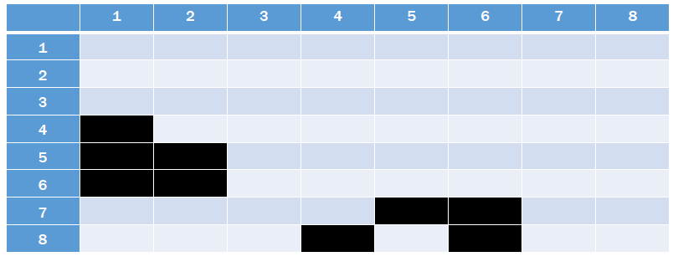

## Risk Analysis

* + Describe the available resources and their allocation in performing the project tasks
* Identify all the potential risks in your project development and provide a mitigation plan

|  |  |  |  |  |
| --- | --- | --- | --- | --- |
| **S/N** | **Risk Description** | **Probability** | **Impact** | **Mitigation Plan** |
| 1 | Unrealistic time estimate | 40% | Significant | Take multiple estimation |
|  |  |  |  |  |
|  |  |  |  |  |

1. **PRODUCT AND PROJECT DESCRIPTION**
   1. **System Features**
2. **Software Sing up**

Functional Requirements:-

* 1. Before use this software, first user shall have to give their some information to sign up on this software.
  2. The software shall have a own secure database. In this database the information that given users will be save and it will analyses when user try to login in this software.
  3. In this software there has two category that user shall have to select before sign up. One is applicant and another is recruitment.

Priority level: High.

Precondition: User have to select one category.

Cross-reference: Null.

1. **Software User Portal**

Functional Requirements:-

* 1. The software UI shall have to be simple or user-friendly that user can operate this software very easily.
  2. As this software is for two category user, it shall have to two different kind of UI.
  3. For category ‘applicant’, this software shall allow the user to see the recruitment post and shall allow to easily comment on this post.
  4. For category ‘requirement’, this software shall allow the user to post for what user need and also can read comment for their post.

Priority level: High.

Precondition: Null.

Cross-reference: Null.

1. **Software Communication**

Functional Requirements:-

* 1. This software shall allow communication features between the users.
  2. There have three kind of communication feature in this software. First one audio. Second one video and last one messaging.
  3. Both of the category users can communicate themselves via audio, video or messaging which they want.

Priority level: High.

Precondition: Null.

Cross-reference: Null.

* 1. **System Quality Attributes**

There are 2 type of perspective of quality attribute. First one is **user perspective** and Second one is **developer perspective**.

Under the **User perspective** there are 8 important primary quality attributes:

1. **Availability:** The system shall be at least 98.5 percent available on every seven days a week between 12.00 am to 11.59 pm at local time.
2. **Efficiency:** There are at least 3.5 percent of the processor capacity, disk space 1.7 MB/S ,memory 120MB and communication bandwidth 512kbps shall be available to properly run this system.
3. **Flexibility:** A maintenance programmer who has at least 8 months of experience shall be able to add new feature and function including code, modifications and testing into the system with no more than three hours.
4. **Interoperability:** When a user sign-up to the system the user has to give some their general information like photo, NID to the system. So, system need to justify the information whether the user given information. For that reason, the system shall be able to import valid information which shall have matched to the user given information. The system shall import the information from local election commission office.
5. **Integrity:** When user try to login into the system, there shall have to two step verification. One step is while user try to login into the system, the system will send a verification code to the user via mail and user shall have to use that verification code to login and the second step is user shall have to use their own password while they create the password to sign up this system.
6. **Reliability:** The system shall no more than three experimental runs out of 800 can be lost.
7. **Robustness:** In the system there are two kind of users. One is applicant and another is recruitment. If the recruitment fails to edit their post before the applicant saves the post, the recruitment shall be able to recover all changes made in the post being edited and shall be able to that edited post within 20 seconds.
8. **Usability:** When the recruitment do post the system shall able to upload that post within 15 second. When applicant see the recruitment post and if the applicant wants to comment to the post. The system shall able to visible that comment to the recruitment within 2 second.

Under the **Developer perspective** there are 4 important primary quality attributes:

1. **Maintainability:** Suppose there is a problem arise in the system that user can’t upload their post. A maintenance programmer who has at least 8 months of experience can solve this problem within 3hour without any extra helping hand.
2. **Portability:** The system must shall able to run any platform or any operating system. Like Windows, Linux, Android, Apple, Unix, Ubuntu, Haiku, Rhapsody etc.
3. **Reusability:** The system functions shall have to be designed in such way that can be reasonable for different any other system.
4. **Testability:** If user want to upload their post, the system shall able to upload that post within 15 second. If the user do comment any post the system shall be able to visible that comment within 2 second. If user communicate with another user via audio or video the system shall able to connect the users within 5 second. If user refresh the page the system will refresh that page within 3 second.
   1. **Project Requirements:**
5. **Time:** We need seven month and one day to build this software.
6. **Environment:** We need an environment to build this software. So, we create an office space ram.
7. **Resources:** We need total 10 human resources to build this software.
8. **Equipment:** To build this software we need equipment. Like, 5 Computer, 5 Table, 1 Marker board.
9. **Bandwidth:** We need high bandwidth support. Which is around 50 to 60 Mbps.
10. **Tools:** The system developer needs selenium tools in perform testing activities in week 6.
11. **SYSTEM DESIGN SPECIFICATION**
    1. **UI Design**

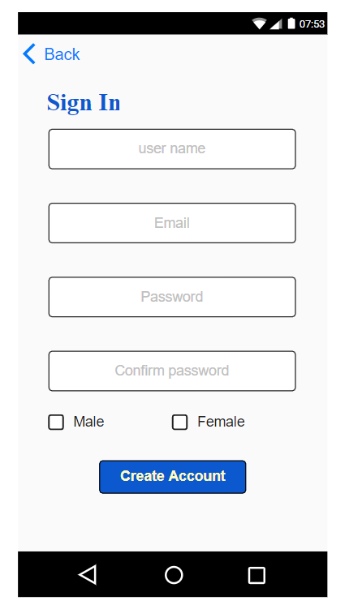

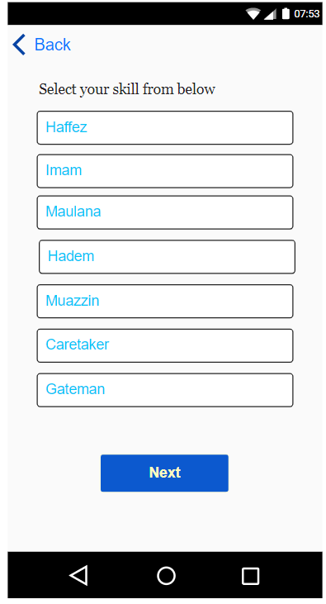

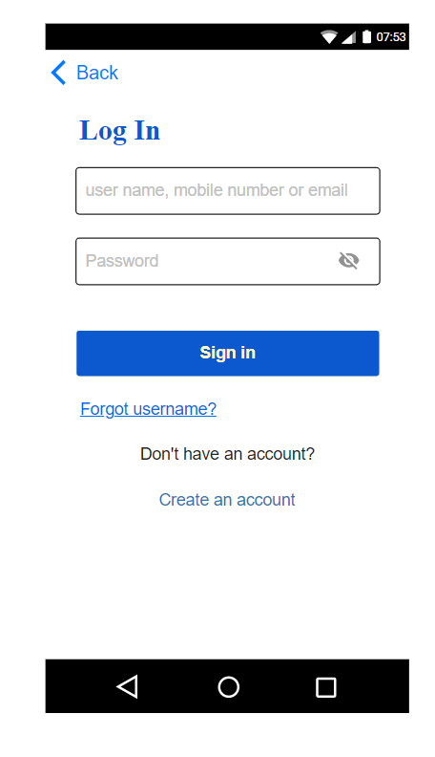

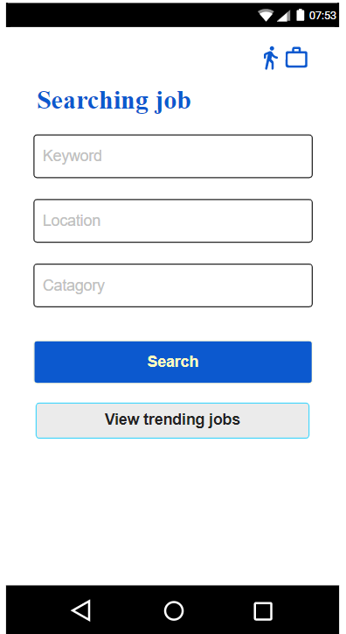

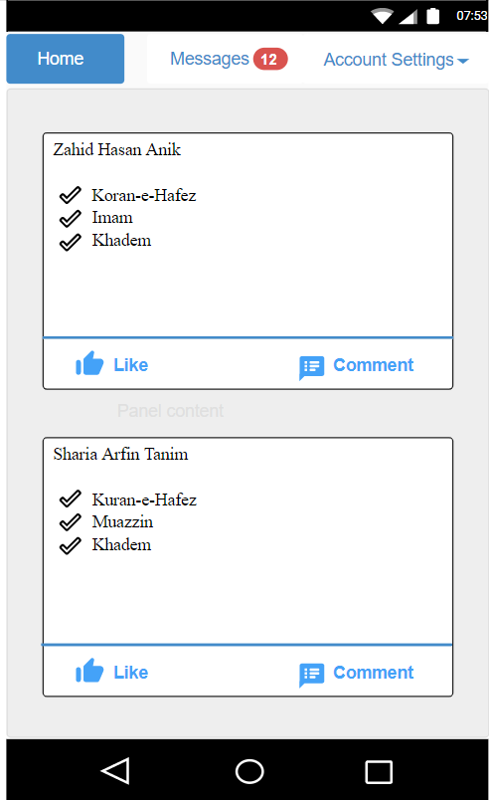

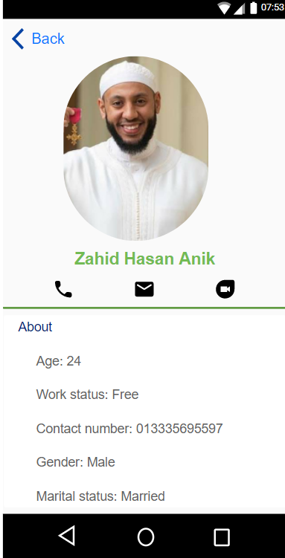

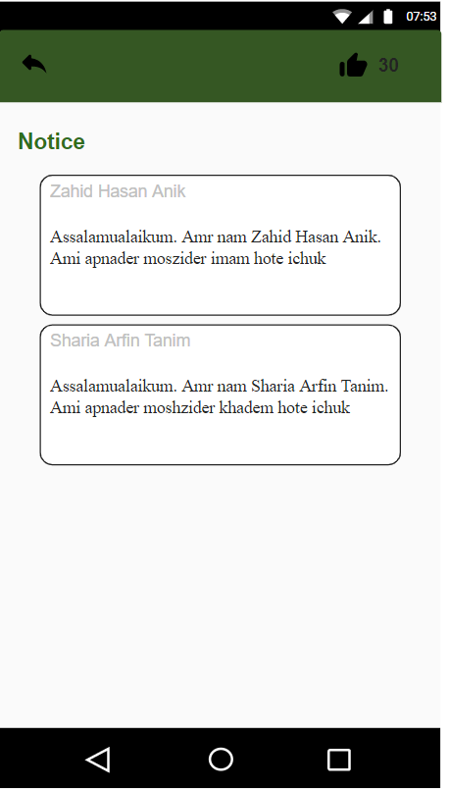

1. **SYSTEM TEST PLAN**

|  |  |  |  |  |  |
| --- | --- | --- | --- | --- | --- |
| Project Name:  Finding Scholar | | | Test Designed by: | | |
| Test Case ID: FR_1 | | | Test Designed date: | | |
| Test Priority (Low, Medium, High): High | | | Test Executed by: | | |
| Module Name: Sing-up Session | | | Test Execution date: | | |
| Test Title: Store user information | | | | | |
| Description: Test sign-up page | | | | | |
| Precondition (If any):  User have to select one category | | | | | |
| Test Steps | Test Data | Expected Results | | Actual Results | Status (Pass/Fail) |
| 1.Go to the sing-up page  2.Fillup information  3.Set password  4.Click submission. | Username: Asif123  Password: 5325 | Information and password should store in database | | As expected | Pass |
| Post Condition: User information is validated and successfully sign-up to account. This information are saved in database. | | | | | |

|  |  |  |  |  |  |
| --- | --- | --- | --- | --- | --- |
| Project Name:  Finding Scholar | | | Test Designed by: | | |
| Test Case ID: FR_2 | | | Test Designed date: | | |
| Test Priority (Low, Medium, High): High | | | Test Executed by: | | |
| Module Name: Communication Session | | | Test Execution date: | | |
| Test Title:  Do communicate between users | | | | | |
| Description: Test communication option | | | | | |
| Precondition (If any):  Null | | | | | |
| Test Steps | Test Data | Expected Results | | Actual Results | Status (Pass/Fail) |
| 1.Go to the communication logo  2.Three communication option  3.Audio,video,chat  4.Option. | Option: Audio, video, chat | User shall successfully communicate via audio, video or chat | | As expected | Pass |
| Post Condition: User is successfully communicate with others. This communication record are save in the database. | | | | | |

|  |  |  |  |  |  |
| --- | --- | --- | --- | --- | --- |
| Project Name:  Finding Scholar | | | Test Designed by: | | |
| Test Case ID: NFR_1 | | | Test Designed date: | | |
| Test Priority (Low, Medium, High): High | | | Test Executed by: | | |
| Module Name: Efficiency | | | Test Execution date: | | |
| Test Title:  Prerequisite to this system | | | | | |
| Description: Test run this software to the user device | | | | | |
| Precondition (If any):  User must have a well configuration device with sufficient bandwidth. | | | | | |
| Test Steps | Test Data | Expected Results | | Actual Results | Status (Pass/Fail) |
| 1.Check processor capacity  2.Check memory  3.Check communication bandwidth. | Processor capacity: 3.5%  Memory: 50MB  Bandwidth: 512 Kbps | The system should easily run to the user device. | | As Expected | Pass |
| Post Condition: The system is running successfully on the user’s device. | | | | | |

|  |  |  |  |  |  |
| --- | --- | --- | --- | --- | --- |
| Project Name:  Finding Scholar | | | Test Designed by: | | |
| Test Case ID: NFR_2 | | | Test Designed date: | | |
| Test Priority (Low, Medium, High): Medium | | | Test Executed by: | | |
| Module Name: Usability | | | Test Execution date: | | |
| Test Title:  User experience | | | | | |
| Description: Test user friendliness of this system | | | | | |
| Precondition (If any):  Null | | | | | |
| Test Steps | Test Data | Expected Results | | Actual Results | Status (Pass/Fail) |
| 1.Check upload time  2.Check comment visibility  3.Check system open time | Upload time:15sec  Comment visibility: 2sec  System open time: 3sec | The system shall able to maintain the test data time. | | As Expected | Pass |
| Post Condition: User experience of this system is user friendliness. | | | | | |

1. **PROJECT MANAGEMENT PLAN**
   1. **Project Scheduling**

|  |  |
| --- | --- |
| **Project Activity** | **Duration** |
| 1. Analysis | 1 week |
| 1. Design | 1 week |
| 1. Development | 2 week |
| 1. Implementation | 3 week |
| 1. Testing | 2 week |
| 1. Deployment | 1 week |

|  |  |  |  |  |  |  |  |  |  |  |
| --- | --- | --- | --- | --- | --- | --- | --- | --- | --- | --- |
| **Week $→$**  **Activity $↓$** | **1** | **2** | **3** | **4** | **5** | **6** | **7** | **8** | **9** | **10** |
| Analysis |  |  |  |  |  |  |  |  |  |  |
| Design |  |  |  |  |  |  |  |  |  |  |
| Development |  |  |  |  |  |  |  |  |  |  |
| Implementation |  |  |  |  |  |  |  |  |  |  |
| Testing |  |  |  |  |  |  |  |  |  |  |
| Deployment |  |  |  |  |  |  |  |  |  |  |

* 1. **Risk Analysis**

|  |  |  |  |  |  |
| --- | --- | --- | --- | --- | --- |
| **S/N** | **Risk Description** | **Probability** | **Impact** | **Priority** | **Mitigation Plan** |
| 1 | User Friendliness | 10% | User count decrease | High | App should be user friendly so that user don’t it hard to use the app |
| 2 | User information leak | 20% | Security issue | High | Protect the database with high security level and give access to few peoples |
| 3 | Unrealistic time estimate | 30% | Project will delay 1 month | Medium | Take multiple estimation |
| 4 | Communication  Error | 40% | Unsuccessful communication can’t connect with scholar | High | Communication should be active all the time |
| 5 | Source code leak | 10% | Security issue | High | Protect the source code with high security level and give access to client and developers. |